User manual for REACH

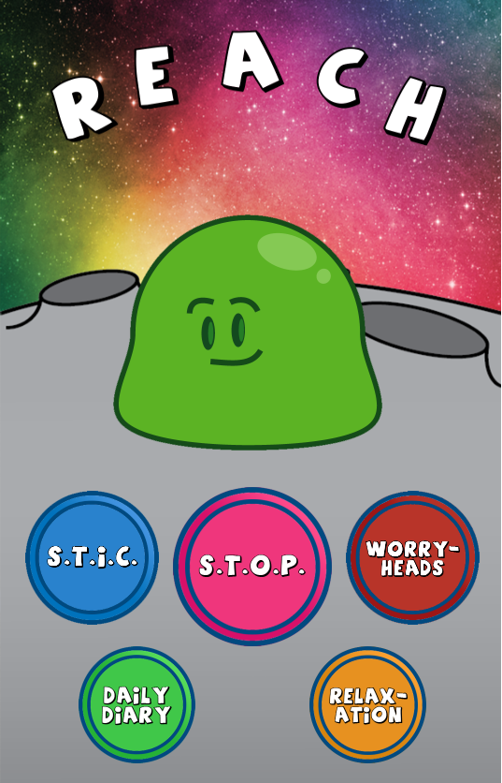

Table of Contents:

1. S.T.I.C.
2. S.T.O.P.
3. WORRY-HEADS
4. DAILY DIARY
5. RELAXATION
6. BOB THE BLOB
7. S.T.I.C.

Tap on the activity you performed in the STIC list.

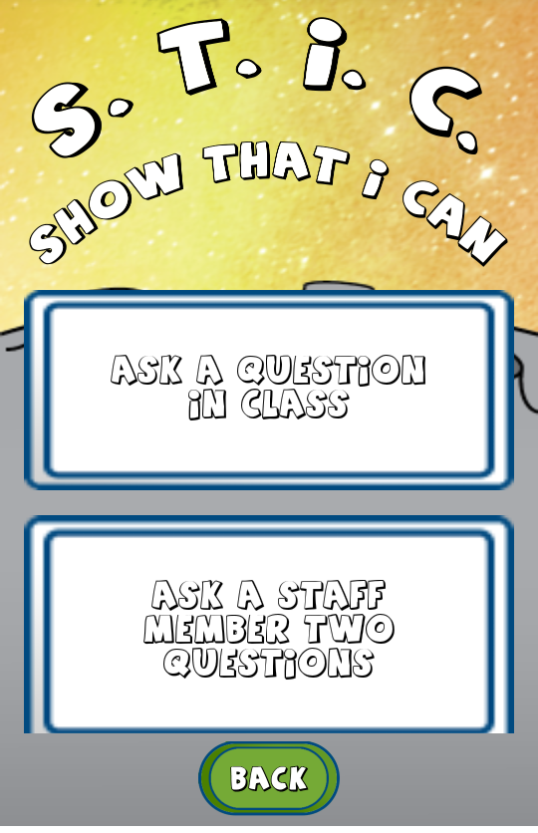

Tap the back button to return to Home Page.

Ask a teacher to give a stamp for completing the activity.

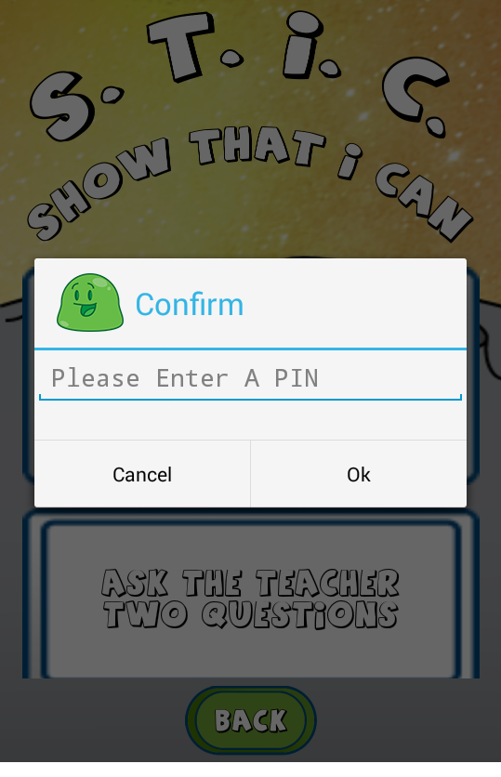

The Activity is completed once the teacher gives you a stamp. Well Done!!

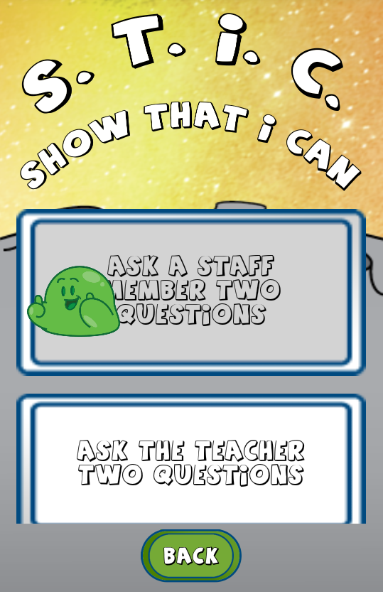

Tap the back button to return to Home Page.

1. S.T.O.P.

Tap the Respond button to give your input for S.

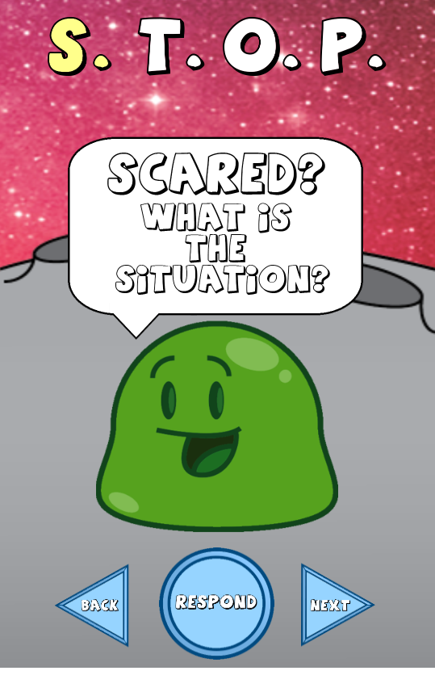

Tap the back button to return to Home Page.

Type in your thoughts using the keypad.

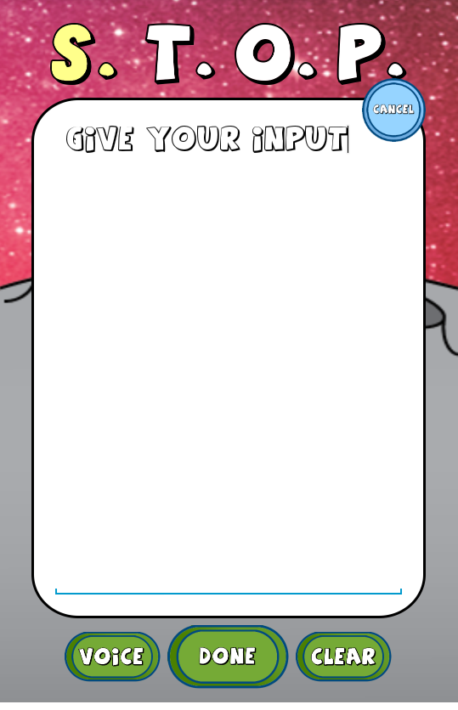

Tap clear button to erase the input and start over again.

Or Instead of typing in, tap the voice button and start talking slowly and clearly, to give input.

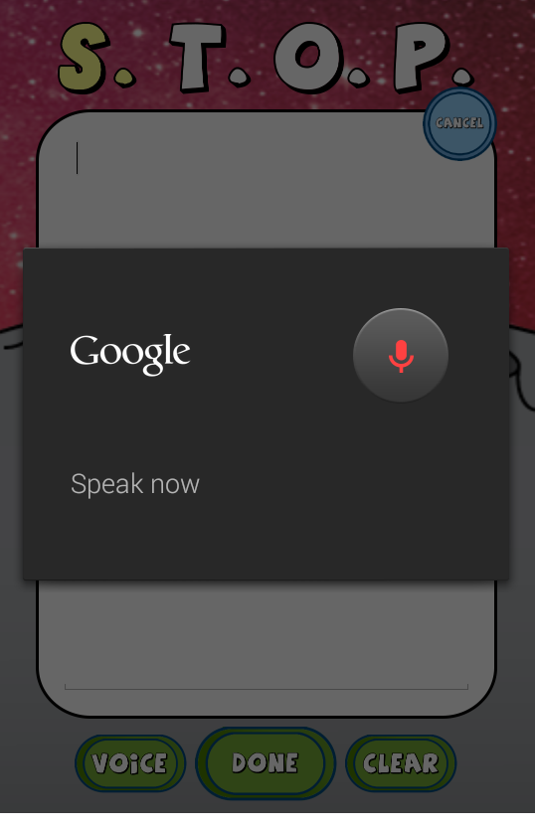

Once you are done speaking, your input will appear in the response section. You can either tap on done button or you can give your input again by repeating the same sequence of actions.

Once you give your inputs, tap on Done button to get the following screen. A tick mark shows that your response is saved successfully. Now tap Next button to proceed to the next activity.

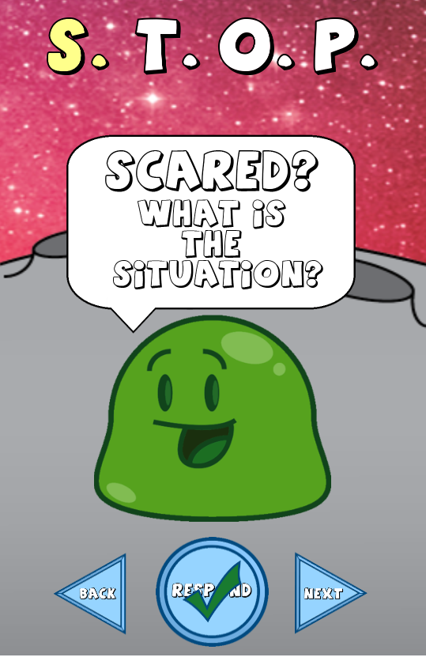

Tap the back button to return to Home Page.

Give your inputs for T in a similar way you did for S and when you are done, tap the Next button to proceed.

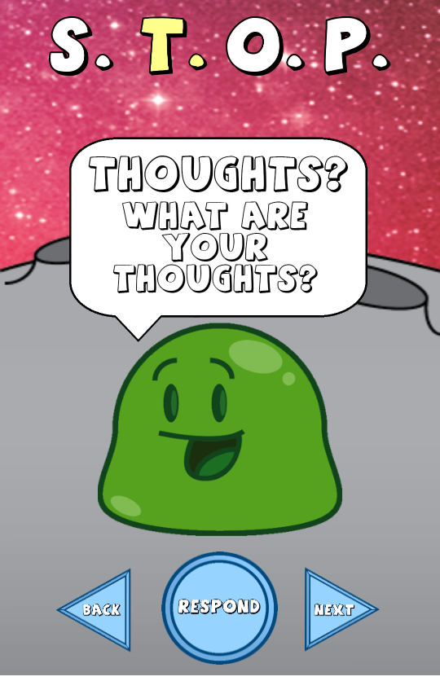

Tap the back button to return to previous activity.

Give your inputs for O in a similar way you did for T and when you are done, tap the Next button to proceed.

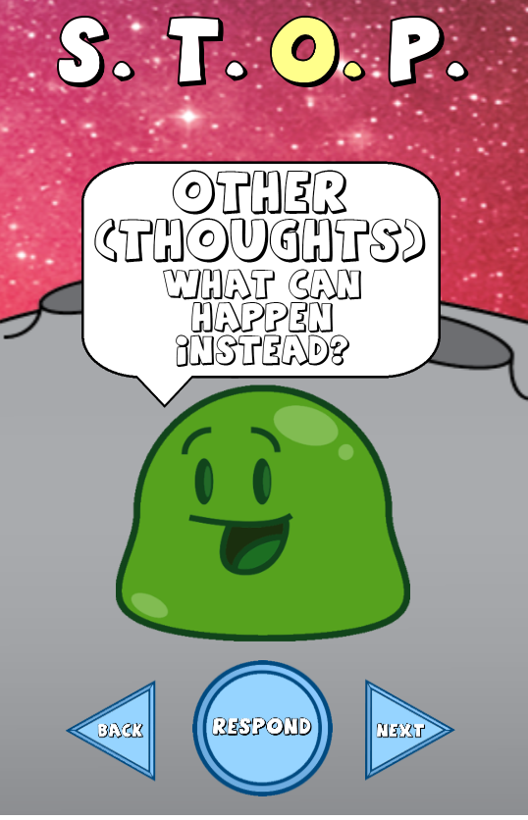

Tap the back button to return to previous activity.

Give your inputs for P in a similar way you did for O. Praise Yourself. When you are done, tap the Next button to proceed.

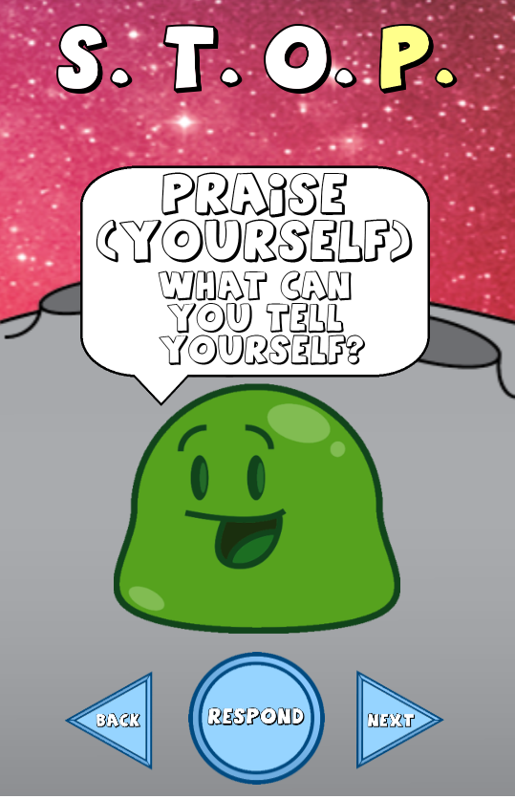

Tap the back button to return to previous activity.

Wohooo!! You have completed the S.T.O.P. activity successfully.

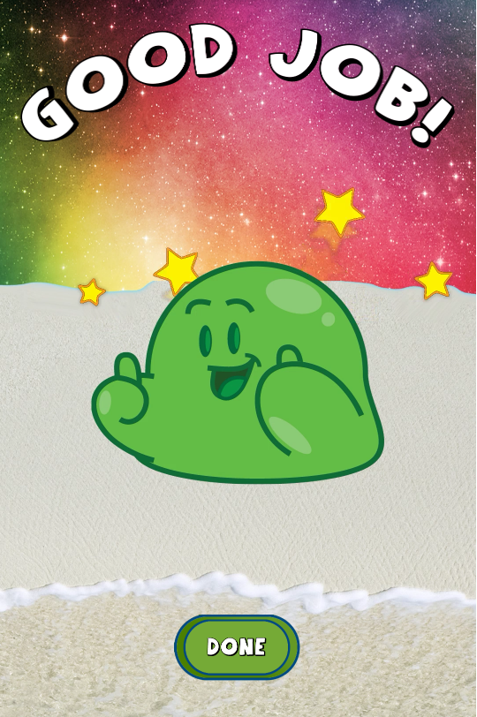

Tap the Done button to return to Home Page.

1. WORRY-HEADS

Read the given **S**ituation and Tap the Next button to go to the next activity.

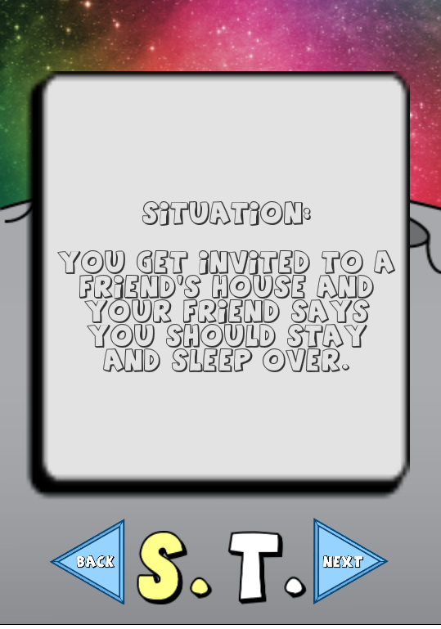

Tap the Back button to return to Home Page.

Read the **T**hought that rises from the **S**ituation and Tap the Next button to go to the next activity.

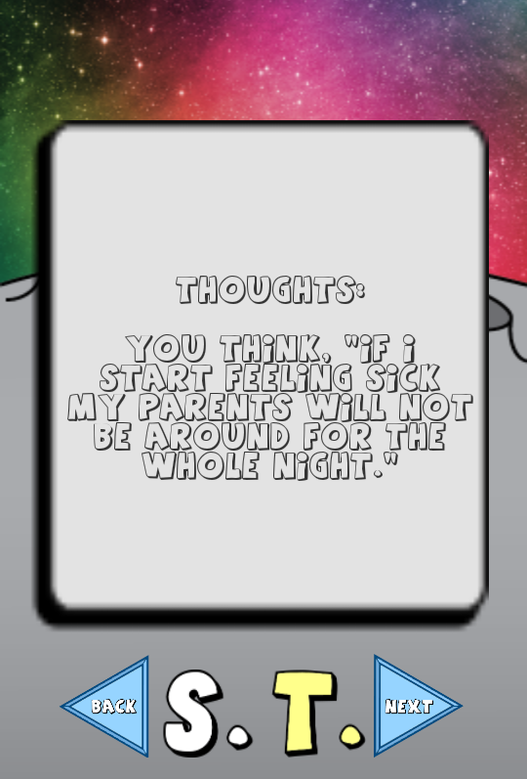

Tap the back button to return to previous activity.

Read all the possible Os based on the S. and T. and Tap the appropriate **O** of your choice.

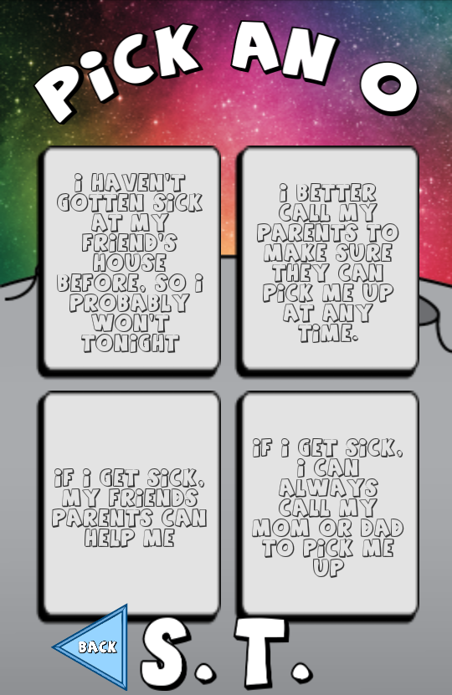

Tap the back button to return to previous activity.

Praise yourself and tap the done button. You have done a great job.

If you want to play one more time, tap on Again button.

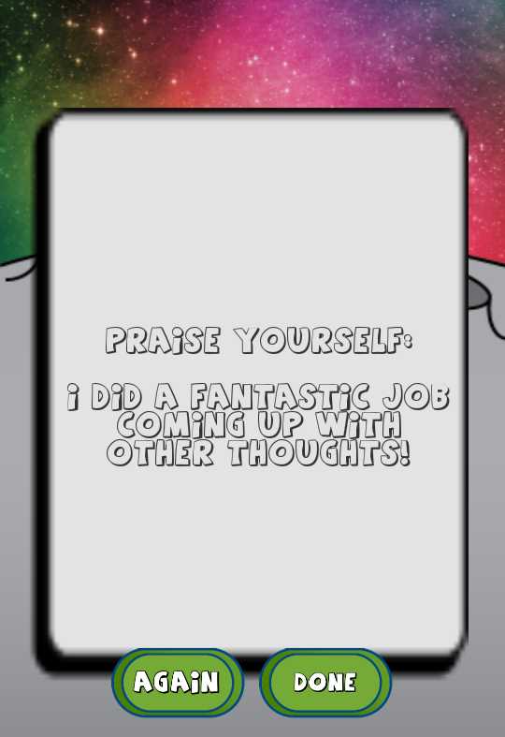

After you tap the Done button it will take you back to Home Page.

1. DAILY DIARY

Tell me what happened? Tap the respond button to give your input either by typing or by giving the voice input. Tap the next button to go to the next activity.

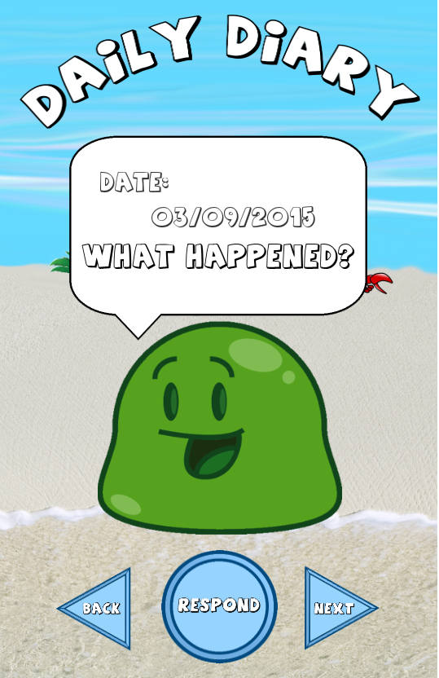

Tap the back button to return to Home Page.

How worried were you? Use the scale to give the input. Tap the white arrows to select the number on a scale or swipe the scale. Tap the next button to go to the next activity.

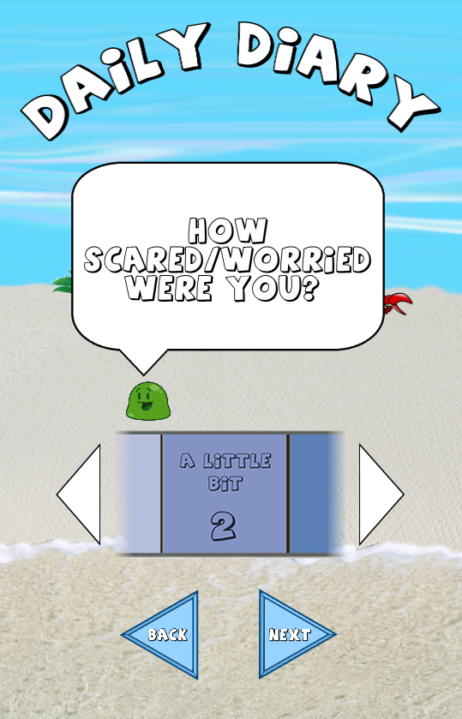

Tap the back button to return to previous activity.

What did you do about it? Give your response and tap on the next button to proceed to the next activity.

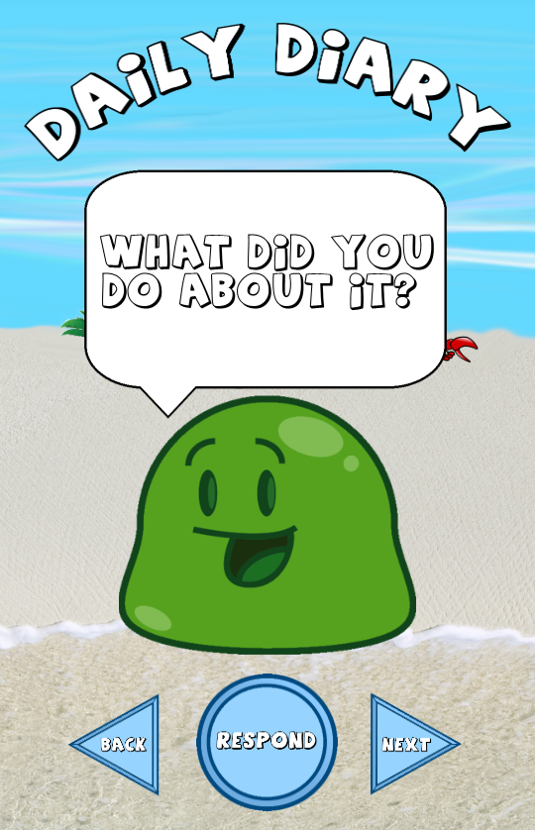

Tap the back button to return to previous activity.

Well done.!! You have completed your daily diary.



Tap the Done button to return to Home Page.

1. RELAXATION

Tap the button of your choice to listen to the relaxation audio.

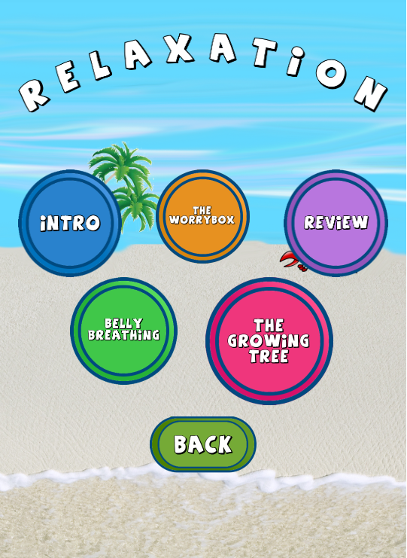

Tap the Back button to return to Home Page.

1. BOB THE BLOB

BOB the BLOB. Tap the button of your choice to see my trick. Complete the daily activities regularly to unlock new tricks.

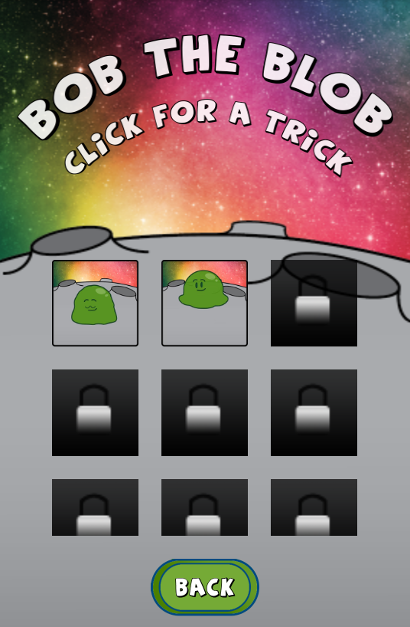

Tap the Back button to return to Home Page.